Expression of Interest
  - Gas Delivery Services
Thursday, 29 February 2024

Table
of contents

1. Background 3
1.1. Who is AusNet? 3
1.2. Intent of this Document 5
1.3. Timelines 6
1.4. EOI Communications 6
2. EOI Overview 7
2.1. Objective 7
2.2. Description and Scope of Services 7
2.3. Estimated Timeframes 14
3. Returnable Schedule: RESPONDENT RESPONSES 15
3.1. Respondent Information 15
3.2. Technical Requirements 16
3.3. Provision of equipment and sub-contracted services 17
3.4. Other Requirements 18
4. Conditions of this EOI 20
4.1. Licence to Use and Intellectual Property Rights 20
4.2. Disclaimer 20
5. Appendix 21
5.1. Appendix 1 - Volume of work performed over the past 5 years 21

Gas Operations & Maintenance, Asset Replacement and Minor Capital Works

- Background

  - Who is AusNet?
AusNet manages a Victorian gas distribution network, transporting gas to approximately 780,000 households and 20,000 businesses across central and western Victoria. This network spans 9,400 kilometres across an area of 60,000 square kilometres. AusNet’s gas distribution area is shown in diagram below.
We're focused on building a safe and reliable gas network for our customers year-round. One of the ways we do this, is by renewing older gas mains.
Over the last 12 months we have upgraded the gas mains in Western Victoria to future-proof the network. We replaced over 70 kms of low-pressure cast iron, PVC and galvanised low-pressure mains with new high-pressure polyethylene pipes (poly pipes). This included upgrading many of the oldest mains in our network across Melbourne’s inner west, Geelong, Ballarat, Bendigo and Colac.
This year we'll continue upgrading mains in Melbourne’s inner west and Geelong and start work on our mains upgrades in Portland, Horsham and Stawell.

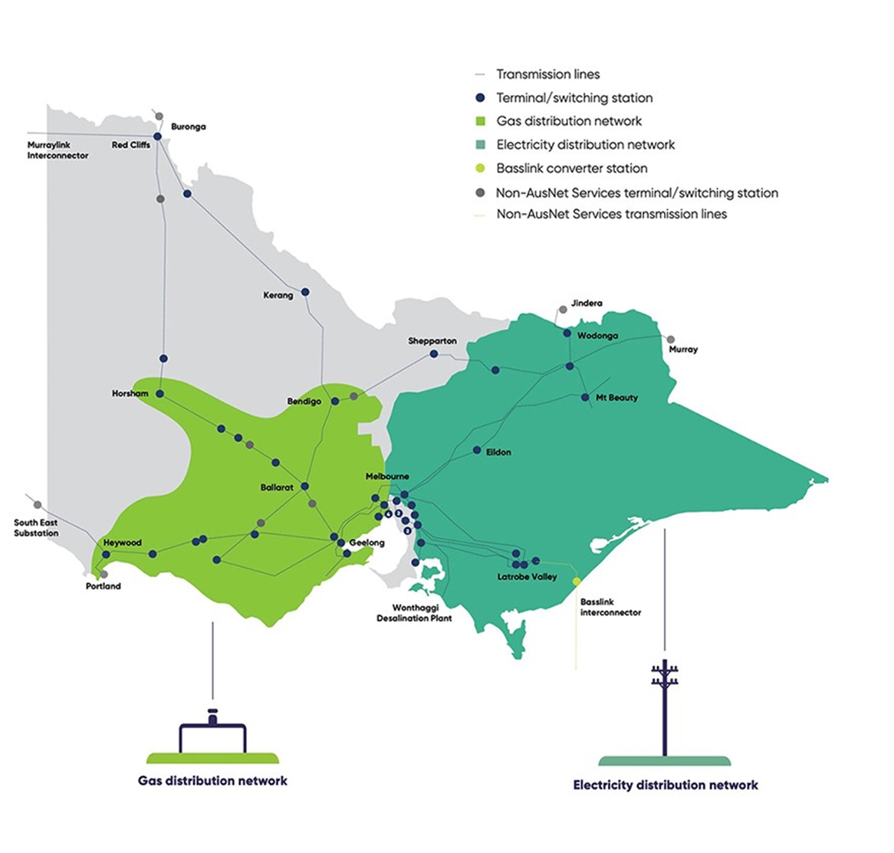
  - Intent of this Document
AusNet is seeking an Expression of Interest (EOI) from suitably qualified and capable Delivery Partners to manage the Gas Operations and Maintenance, Asset Replacement, Minor Capital Works and Gas Meter Reading of the Gas Distribution Network for AusNet.
The information provided by respondents, will be used to inform AusNet of interested and capable Delivery Partners and/or Suppliers to support AusNet’s next phase in the procurement activity.
AusNet is expecting a capability statement, that addresses the information contained in the Description and Scope of the Services. Further information is detailed in Description of response from EOI participants.

Who are we looking for?
AusNet is seeking a response from Delivery Partners who have the capability and experience to support AusNet’s objectives both in the volume of work and diversity of the activities involved in
- Operation and Maintenance
- Asset Replacement,
- Minor Capital and
- Gas Meter Reading works
within AusNet’s Gas Distribution Network.
AusNet’s preference is to have responses from organisations who have undertaken similar sized activities in other Gas or Water Distribution businesses.
Appendix 1 contains the approximate volume of each activity that has been performed over the last [5] years.

This EOI comprises three sections:
- Section (1) – Background
- Section (2) – EOI Overview
- Section (3) – Respondent’s Returnable Schedule; and
- Section (4) – Conditions of this Expression of Interest (EOI)

Note: If Respondent’s organisation is part of any AusNet’s existing panel, or has a valid Master Panel Agreement with AusNet, responses to Section 3.5 Other Requirements will be optional.

This EOI is not an offer.
It is an invitation for persons to submit a response only. Please take time to read and understand the EOI requirements.
Returnable schedules are provided for your use. However, we understand that you may wish to submit using your corporate format. If you choose to do this, please ensure your response has clear and specific references to the returnable schedules (including, as a minimum, both the number of the schedule and the number of the question) to enable the AusNet Services team to efficiently review your responses.
Please include other information that your organisation deems relevant to improve the outcome of the intent of this EOI exercise.

  - Timelines
The indicative key dates and activities are shown below:
Thurs, 29 Feb 2024 | EOI issued
By Tues, 5 Mar 2024 | Respondent confirmation of intention to submit EOI response
Tues, 26 Mar 2024 | Deadline for requests for further information (3 Business Days prior to EOI response due date)
Fri, 29 Mar 2024 | EOI response submission due date at 4pm AEST
Qtr2 2024 | EOI evaluation complete
Qtr3 2024 | Notification & Comms on EOI to participants
TBA | Shortlisting of Respondent(s) to participate in RFx
TBA | RFx Evaluation completion and preferred Service Provider selected
By Early 2026 | Contract commencement

  - EOI Communications
Please direct and submit all clarification questions or communications to the EOI contact below:
Contact | Danielle Khoo (Category and Commercial Manager)
Email | Danielle.Khoo@ausnetservices.com.au

- EOI Overview

  - Objective
The purpose of this Request for Expression of Interest (EOI) is to seek from suitably qualified and capable Delivery Partners to manage the Gas Operations and Maintenance, Asset Replacement, Minor Capital Works and Gas Meter Reading of the Gas Distribution Network for AusNet.

  - Description and Scope of Services

Operations and Maintenance
- Scheduled and unscheduled maintenance
- Inspections and condition monitoring
- 24/7 Emergency management & response
- Customer initiated capital projects.
- Disconnections

Asset Replacement
- Scheduled and unscheduled maintenance
- Asset replacement or relocations
- 24/7 Emergency management & response
- Company initiated capital projects.

Minor Capital Works
- New connections
- Customer initiated capital projects.
- Minor Company initiated capital projects.

The key services are currently delivered by three business areas:
Mains & Services: - Maintenance, inspections and minor capital works on the distribution network.
Systems Operations: - Maintenance, inspections and minor capital works on pressure regulation and other strategic equipment on the transmission and distribution network.
Gas Supply: - Maintenance works, inspections, retailer requests and replacement programs for domestic, industrial and commercial metering equipment located on the distribution network.

Planned Maintenance
The Delivery Partner is responsible for co-ordination planning and execution of all planned maintenance activities on the Gas Network. This responsibility extends from the outlet of custody transfer stations on the external transmission network up to the meter outlet at domestic or commercial premises. Planned maintenance is conducted in accordance with plans, standard procedures, operating manuals and strategies developed by AusNet and relevant external parties.

Unplanned Maintenance
The Delivery Partner is responsible for co-ordination and execution of all unplanned maintenance activities on the Gas Network. This responsibility extends from custody transfer stations on transmission pipelines up to the meter at domestic or commercial premises. Unplanned maintenance will predominately be related to gas escapes, system operation faults and customer requested work, consequently the responsibility includes mains, services and system operations. Unplanned maintenance is conducted in accordance with plans, standard procedures, operating manuals and strategies developed by AusNet and relevant external parties.

Asset Replacement
The Delivery Partner is responsible for co-ordination and execution of all asset replacement activities on the Gas Network. Asset replacement will predominately be replacement of minor gas assets that are no longer able to be repaired in accordance with AusNet’s procedures, or substantive repair works that essentially replace the asset such that the operating life of the asset is significantly increased. Asset replacement is conducted in accordance with plans, standard procedures, operating manuals and strategies developed by AusNet and relevant external parties.
Asset replacement will include work carried out in response to identified problems or defects and could relate to:
- City Gate regulators
- Field regulators
- District regulators
- I&C regulators
- Heaters
- Renewal of defective domestic regulators and meters
- Renewal of defective service
- Renewal of defective main < 20m in length
- Minor lower/alter main or service.

Minor Capital Works
AusNet has an Installation Delivery Partner Panel (ISP Panel) established for the execution of major and minor capital works.
However, in certain circumstances, the Delivery Partner will be afforded the opportunity to provide minor capital works as part of the Gas Work Package. Minor capital works will predominately be replacement or extension of existing gas assets, or creation of new gas assets on the Gas Network. Minor capital works is conducted in accordance with plans, standard procedures, operating manuals and strategies developed by AusNet and relevant external parties.
Minor capital works include:
- Installation of new mains and services
- Supply enlargement
- Replacement of existing mains
- Supply reinforcement
- Back bone infrastructure
- New estates
- New meters, regulators and supply connections.
- Gas Shippers (complex supply connections)
- 3rd Party Alteration Management Services
- Gas New Estates Management Services

Gas Meter Reading
Providing gas meter reading services – Cyclic Meter Reading and Special Meter Reading Services – to approximately 682,000 regulated gas customers across the AusNet Services gas distribution network.

Supporting activities
Supporting activities are those that assist, lead up to, or follow on from the key services described in the previous section. These supporting activities form part of the overall services to be provided by the Delivery Partner.

Operations
- Assigning and managing resources
- Planning and scheduling of work
- Construction project control and management
- Material sourcing, procurement and logistics
- HSEQ management
- Financial management
- Asset management
- Documentation
- Reporting
- Asset security
- Engineering support activities

Infrastructure
- Information Technology and information management

People
- Human resources/Industrial relations management
- Subcontractor management
- Training
- Where required, ensuring personnel have appropriate background checks

Assigning and Managing Resources
The Delivery Partner shall assign and manage resources to meet the scheduled work plan and to manage all emergency response activities. This includes, but is not limited to:
- Work scheduling and planning
- Management of field activities and resources
- 24/7 availability management
- Fleet and equipment management.
- Procurement and management of all materials including gas meters

The Delivery Partner must ensure that all personnel carrying out services on the Gas Network must have all necessary qualifications and permits.
The Delivery Partner must also at all times ensure that the services are supplied through use of a sufficient number of appropriately trained and qualified personnel.

Planning and Scheduling of work
The Delivery Partner is required to plan and schedule all work to meet AusNet, developer or customer completion dates. Where required, the Delivery Partner shall liaise directly with the developers or customers to determine project planning & scheduling requirements.
The Delivery Partner shall be responsible for organising all travel to and from the worksite in the most efficient manner.

Construction project control and Management
The Delivery Partner will be responsible for project managing construction works. This includes but is not limited to:
- Defining and scheduling all activities required to deliver scope of works
- Assigning appropriate resources to deliver activities
- Ongoing management of work activities required to deliver scope of works within agreed timelines, costs and quality levels
- Ongoing management and reporting of issues and risks in accordance with AusNet requirements
- Project closure and post implementation review.

Material Sourcing, Procurement and Logistics
Material sourcing, procurement and logistics are divided into four categories. The Delivery Partner shall be responsible for all unloading, storage, security and stock control of all material and spare equipment items, regardless of the category of the items. The Delivery Partner shall also be responsible for management of all materials removed from the Gas Network in performing the services and the disposal of scrap in accordance with the Agreement.
Category 1: Strategic Spares
Category 2: Gas Meter Management Services (including acquisition of Gas Meters)
Category 3: Delivery Partner Supplied Materials
Category 4: Joint Procurement

Health Safety, Environmental and Quality
AusNet has an active HSEQ Department which will work with the Delivery Partners to ensure the delivery of HSEQ in accordance with AusNet’s strategic goals and corporate reputation.
The principles of the relationship between AusNet and the Delivery Partner are based upon the following allocation of responsibilities.
AusNet, through the life of the Agreement, will:
- Conduct HSEQ and regulatory audits across the Delivery Partner’s business as applicable to the contract to obtain assurance that the systems and practices are compliant with AusNet’s general and regulatory requirements
- Prepare performance reports based upon the above audits and operational systems data to obtain assurance that the level of compliance is within contractual requirements
- Conduct management system audits to ensure it is suitable and appropriate for providing services to AusNet under the contract and compliant with the requirements of the Gas Safety (Safety Case) Regulation, ISO9001, ISO14001 and AS4801 certifications.
AusNet expects the Delivery Partner to:
- Develop and maintain an audit program covering HSEQ system and operational activities based on AusNet requirements documented in QMS 21-11. The audit program will be vetted by AusNet
- Provide regular HSEQ performance reports and corrective action summaries to AusNet Quality Manager
- Provide technical HSEQ assistance across issues identified through the management of systems and operational activities

- Provide technical HSEQ assistance to investigate and determine the root cause of incidents and events leading to non-compliance with Gas Safety (Safety Case) Regulations, ISO9001, ISO14001 and AS4801 certifications
- Develop and provide to employees Health, Safety and Environment work practice and operating training in accordance with industry requirements
- Provide representation at Works Practices, Health, Safety and Environment specific meetings
- Provide timely promulgation of HSEQ alerts, reports, technical bulletins, works practices and standards.
- Immediately report the occurrence of an incident and log the incident in Enablon (AusNet Incidence Management System) within 24 hours.
- Where required, assist AusNet to comply with its regulatory obligations, in particular, under the Security of Critical Infrastructure Act 2018 (Cth) and the Rules under that Act (“SOCI”).

Both AusNet and the Delivery Partner will:
- Jointly manage incident investigations and corrective action activities through Enablon - AusNet Issues Management System (IMS)
- Incidents and corrective actions appropriate to the contract, including sub-contractors, will be logged into the Enablon. Incidents include:

  - Near Hit
  - First Aid
  - Medical Treatment
  - Lost Time
  - Fatalities
  - Asset Incidents

- Motor vehicle and plant incidents and corrective actions not applicable to the contract need not be logged in Enablon
- Jointly review and agree on appropriate remedial action resulting from incidents, audits, corrective action and process improvement
- Jointly participate in regulatory audits under the Gas Safety (Safety Case) Regulation conducted by Energy Safe Victoria
- Jointly agree on improvement opportunities around systems and processes appropriate to the contract.

Financial Management
The Delivery Partner is required to provide:
- Financial reports, including forecasts and accruals
- Assistance with AusNet financial audits
- Monthly activity reports including completed works and work in progress to end of month
- Adequate monthly records so as to substantiate all actual costs incurred
- Monthly headcount report of FTEs providing indirect support.

Asset Management
The Delivery Partner is required to provide reasonable assistance to AusNet with the:
- Assessment of new plant and equipment.
- Identification of local Gas Network issues relating to capacity, reliability & quality
- Development of asset management strategies and policies.

Documentation
The Delivery Partner is required to capture and maintain all data and hard copy documentation relating to work performed for and on behalf of AusNet and provide it to AusNet as required.
The database/hard copy files must be maintained to acceptable standards and be complete and available upon request by AusNet. Information to be managed includes but is not limited to:
- Customer details
- Completed works details including personnel utilised to perform the work
- Formal request correspondence
- Correspondence relating to reinstatement
- Other correspondence with customers/retailers/other parties
- Incident reports
- Damage forms and reports
- Maintenance worksheets/check sheets
- As-built drawings
- Asset clearance forms
- Permits
- Gas Field Procedures (GFP) that meets AusNet’s and industry technical standards and required legislation.

Reporting
The Delivery Partner is required to provide timely and accurate reports to AusNet as required, including but not limited to:
- Cost variation reporting
- KPI reporting
- Client reporting
- Regulatory reporting, including but not limited to reporting against AusNet’s SOCI obligations
- HS&E reporting
- Incident reporting
- Claims and complaints reporting
- Recoverable works reporting, including details of parties causing damage to assets
- New Connections and Truck Appointments issues including wasted visits, no access, defective sites and missed GSL details.

Asset Security
The Delivery Partner will be required to provide daily patrols to prevent intrusion into the safe operating zones of the Gas Network, and supervision of third parties operating within the safe operating zones of the Gas Network.

Engineering Support Activities
The Delivery Partner will be required to provide general engineering support to AusNet, including:
- Design
- Drawings & drawings management
- Reporting
- Network information to authorised third parties
- Permits and approvals (issuing and evaluating both Distribution and Transmission)
- Stakeholder communications
- Responding to defective materials
- Maintenance and upkeep of existing standard procedures and development of any new standard procedures as site/work conditions influence.

Information Technology
The Delivery Partner will be responsible for provision and maintenance of its own IT infrastructure and systems, including Helpdesk and desktop support plus ownership and hardware requirements.
In order to undertake and complete the works, the Delivery Partner is required to download information from, and upload information to AusNet systems.

Human resources and Industrial relations Management
The Delivery Partner is required to manage all Human Resources and Industrial Relations related its employee and subcontractor workforce, including but not limited to:
- Recruitment
- Payroll
- Enterprise Bargaining Agreement negotiations
- Industrial dispute resolution
- Employee development programs
- Performance management.

Subcontractor Management
The Delivery Partner is required to manage all sub-contractors, including but not limited to:
- Implementation and maintenance of a sub-contractor management system
- Field, system and quality audits of sub-contractors
- Sub-contractor inductions.

Training
The Delivery Partner must ensure that all mandated and other necessary training, as well as refresher training has been received and must meet all costs associated with such training.
Delivery Partner must also ensure that all minimum industry requirements are met and adhered to.

Approval for Extraordinary works
The Delivery Partner must seek AusNet's written consent to the carrying out of any activities that may require extraordinary costs, or additional costs above the applicable standard Unitised Direct Cost for those activities.
Examples of activities that may require extraordinary costs include, but are not limited to, directional drilling, extensions or alterations to a new mains, the laying of multiple extensions, additional reinstatement requirements and heater repair works.

  - Estimated Timeframes
AusNet estimated timeframe for engagement to commence in the event of a RFx for the same scope of works is being issued and awarded is expected to be to be around early March 2026.

- Returnable Schedule: RESPONDENT RESPONSES
Submitted EOI must provide a response to the following for consideration:

  - Respondent Information

1. Please complete the following table:
Question | Response
Organisation name
ABN
Key contact’s name
Key contact’s position
Telephone number
Email address

Item | Requirement | Respondent’s Response
2 | Please list services that your organisation may provide in support of the scope of works.
3 | State whether the Respondent/your organisation has any conflicts of interest (including any actual or potential), such as:  - Personal conflicts resulting from relationships between personnel of the Respondent and AusNet Services.  - Commercial conflicts resulting from the Respondent having to allocate resources between AusNet Services and any competitors of AusNet Services to which the Respondent also provides services.  in the event that your organisation is selected to participate in future RFx relating to deliver any part of the scope of works or engaged to deliver any part of the scope of works in the future.

  - Technical Requirements
The submissions regarding technical requirements shall include the following:
AusNet is seeking a capability statement, describing the experience your organisation has against each item specified in the Description and Scope of the Services.
Additionally, detailing the experience the Delivery Partner has to meet the volume or work detailed in Appendix 1.
Ausnet is also seeking an estimate of time you will require to scale up (mobilisation) to meet the volume of work described in Appendix 1.

Furthermore, AusNet is seeking:
- the names of existing clients you are currently serving
- the number years in services with the relevant client and
- the volume of works you provide for them
- an understanding of your organisation preferred customer relation model with your clients/ potential clients including
- what contracting models/ frameworks your organisation operates under i.e. fixed unit rate, fixed margin / open book, alliance etc

  - Provision of equipment and sub-contracted services
Item | Requirement | Respondent’s Response
1 | Does your company have any specific agreements with subcontractor companies, and if so, how would AusNet benefit from those agreements (operationally and commercially)?
2 | Does your company use any preferred suppliers in the delivery of services?  If yes, please list their names, relevant scope of works engaged for and the no. of years you have been using the preferred suppliers.

  - Other Requirements
Respondents are to also to provide an overview and responses to the following.
Note: If Respondent’s organisation is part of any AusNet’s existing panel, or has a valid Master Panel Agreement with AusNet, the following responses are optional

Financial Viability
            - Provide the following financial information for your Australian operations (total business) in $AUD

Financial Information | FY21 | FY22 | FY23
Total Revenue | <insert> | <insert> | <insert>
Gross Margin | <insert> | <insert> | <insert>
Net Income | <insert> | <insert> | <insert>
Total Asset | <insert> | <insert> | <insert>

Item | Requirement | Respondent’s Response
Financial Viability
2 | Specify the proportion of revenue coming from your Top 5 clients
3 | Is the Respondent solvent and able to meet its debts as and when they fall due in the normal course of business?
HSEQ & Accreditation
1 | Demonstrate commitment to health, safety and wellbeing, environmental management and quality assurance
2 | Please provide a copy of any independent accreditations of the organisation’s HSE Management System
3 | Does your organisation currently hold accreditation services administered by CM3?  Note: The respondent’s organisation must obtain and maintain, at its own expense, accreditation to work on AusNet’s gas network. This accreditation is administered by Cm3 an outsourced provider of accreditation services.
Insurances
4 | Does your organisation have at minimum the following:  - Public and Product Liability Insurances  $100 million for any one occurrence for the duration of the Term  - Professional Indemnity  Not less than $20 million in respect of any one claim and in the aggregate.  - Motor Vehicle Third Party Property Insurance  Not less than $20 million for any one occurrence  - Valid Workers Compensation Insurance

- Conditions of this EOI

  - Licence to Use and Intellectual Property Rights
Persons obtaining or receiving this EOI Package, and any other documents issued in relation to the EOI
Process may use the EOI Package and such documents only for the purpose of preparing a response.

Such Intellectual Property Rights as may exist in the EOI Package, and any other documents provided.
to Respondents by or on behalf of AusNet Services in connection with the EOI Process are owned by
(and will remain the property of) AusNet Services except to the extent expressly provided otherwise.

  - Disclaimer
AusNet Services provides the information in this EOI Package (comprising this document, any
schedules, appendices, attachments and addenda) on the basis that neither AusNet Services nor its
related entities (as defined in the Corporations Act (2001) Cth) or its employees, agents, offices or
servants accept any responsibility to any Respondents or to any third parties for any loss or damage
which may arise from any information provided in relation to the EOI or to the provision of the Works,
whether or not it forms part of this EOI, or has been supplied or will be supplied separately to the
Respondents.

Neither AusNet Services nor any of its related entities (as defined in the Corporations Act (2001) Cth),
provide any warranty or representation as to the accuracy or completeness of the information
contained in this EOI Package.

Information and assistance provided by AusNet Services does not affect the responsibility of
Respondents to independently assess, manage and bear the risks associated with preparing
quotations and, if selected, implementing the Works. Any comments, statements, information, or data
provided to Respondent by AusNet Services in relation to the Works are subject without limitation to
the terms of this EOI.
This EOI is not an offer. It is an invitation for persons to submit a response only. This EOI must not be
construed, interpreted, or relied upon, whether expressly or impliedly, as an offer capable of
acceptance by any person. AusNet Services is under no obligation to complete the process outlined in
this EOI or to proceed with the Project. AusNet Services may change the process, or the description.
of the requirements outlined in this EOI by issuing an Addendum to Respondents.

AusNet Services will not be liable for any costs incurred by Respondents through considering this
opportunity, submitting a response, or otherwise participating in the EOI.

- Appendix

  - Appendix 1 - Volume of work performed over the past 5 years
The listing represents rough historical volumes and cannot be used as an indicator of future work volumes.

 | Indicative Annual Amount
New Domestic Gas Service and Meter Installations | 18,000 to 24,000
Complex Customer Connections (gas service and meter) | 300 to 400
New Estate Gas Main Installations | 125 km to 170 km
Minor Asset Relocations (i.e. gas services and/or meters) | 200 to 300
Major Asset Relocations (i.e. gas mains etc). | 40 to 50
Gas Service Disconnections | 1800 to 2200
Meter Replacements | 20,000 to 30,000
Planned Maintenance Items | 150 to 200
Planned Inspections | 3250 to 3750
Site Maintenance Visits | 400 to 500
Corrective Maintenance Items | 2800 to 3200
Fault or Emergency Items | 15,000 to 25,000
Temporary Meter Disconnections (Metro) | 9,500 to 10,500
Temporary Meter Disconnections (Regional) | 16,000 to 18,000
Gas Meter Reads (Metro) | 2,000,000 to 2,500,000
Gas Meter Reads (Regional) | 2,500,000 to 3,000,000
Special Gas Meter Reads (Ad-Hoc) (Metro) | 110,000 to 120,000
Special Gas Meter Reads (Ad-Hoc) (Regional) | 150,000 to 170,000

